AAVISHKAR PRAVAH 2.0 | HEALTHCARE INNOVATION
Unifying the Clinical Picture
QR Medical Record System
"One scan to link every piece of a patient's story"
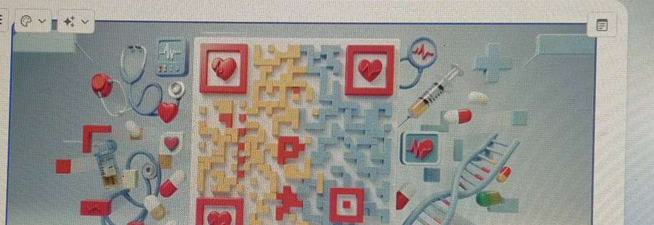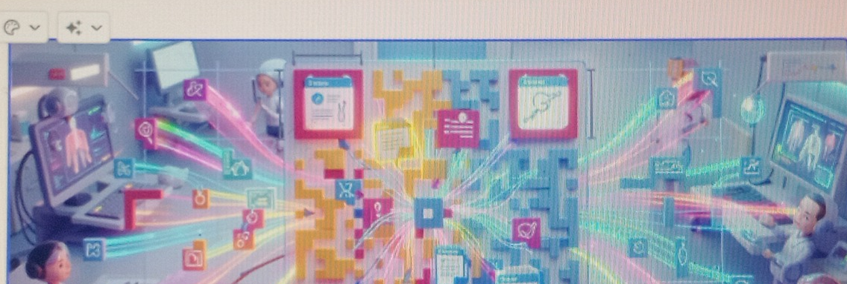
Left: Medical QR code concept — stethoscopes, DNA & health data encoded in one scan | Right: AI-powered data network connecting all healthcare systems

Team  Pikhachu | Event  Aavishkar Pravah 2.0 | Track  Healthcare Tech | Date  May 2026

Abhinaya S • A V Varshini Suma • Mohammed Touseef • Aiman Shariff

1. Problem Statement
Patient medical histories are scattered across disconnected healthcare systems — hospitals, clinics, pharmacies, and labs each hold isolated records with no interoperability. Physicians make critical decisions without complete information, leading to medication errors, duplicate testing, delayed diagnoses, and compromised patient safety.

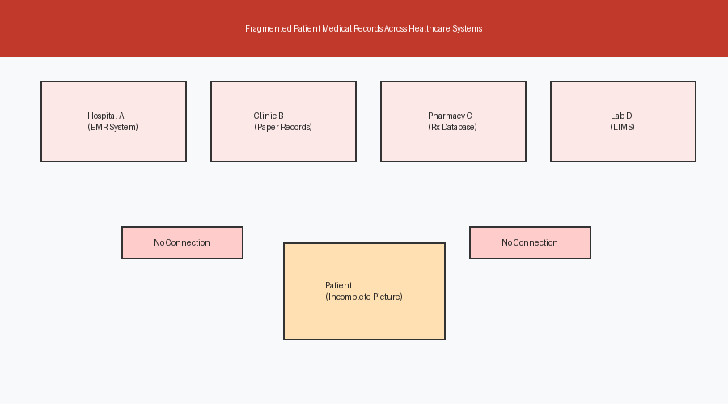
Figure 1: Fragmented patient records trapped across disconnected provider systems
72%  Patients with records in multiple systems | 30%  Medical errors from incomplete data | 45 min  Avg. delay accessing complete records | 3.5x  Better outcomes with unified records

2. Our Solution: QR Medical Record System
Team Pikhachu proposes a QR-code-based unified patient identity system. Each patient receives a single encrypted QR code that acts as a universal key to their complete medical history — accessible instantly by any authorised provider, anywhere.


The QR Medical Record — a single scan encodes the patient's complete health identity: diagnoses, medications, allergies, lab results, DNA markers, and imaging history

What the QR Code Contains

How It Works — Step by Step
- Patient registers once → receives their unique encrypted QR code (physical card + digital app)
- Patient presents QR at any healthcare touchpoint — clinic, hospital, pharmacy, or emergency room
- Clinician scans the QR → instantly accesses the patient's complete, up-to-date medical history
- AI engine cross-checks medications for interactions, flags allergies, and surfaces risk scores
- New data (prescriptions, test results, diagnoses) is automatically added to the patient's record
- Patient controls access — can grant or revoke consent per provider via the mobile app

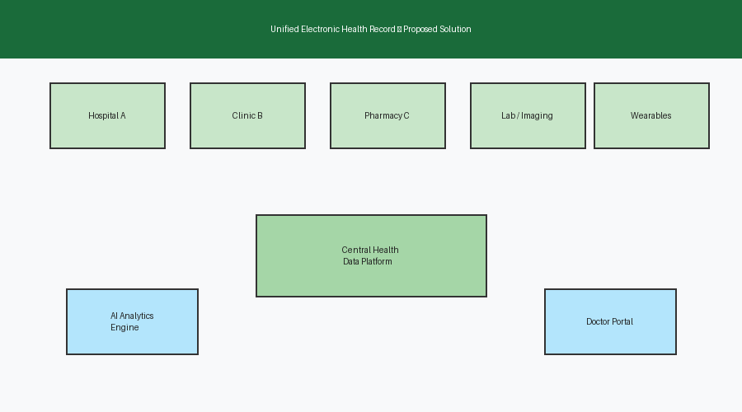
Figure 2: Centralised health data platform — all providers connected through a single QR-linked patient identity

Security & Privacy
AES-256 Encryption | All data in the QR and platform is encrypted end-to-end
Zero-Knowledge Auth | Clinicians verify identity without ever seeing raw credentials
Patient Consent Control | Patients grant or revoke access per provider, per visit
Rotating QR Tokens | QR code refreshes cryptographically — cannot be cloned or reused
Full Audit Trail | Every data access event is logged with timestamp and provider ID
DPDP Act Compliant | Fully compliant with India's Digital Personal Data Protection Act

3. AI & Technology Stack
The platform pairs the QR identity layer with a powerful AI analytics engine that transforms raw patient data into actionable clinical intelligence — shifting care from reactive to proactive.


Figure 3: AI-powered data network — real-time intelligence connecting patients, clinicians, and health systems

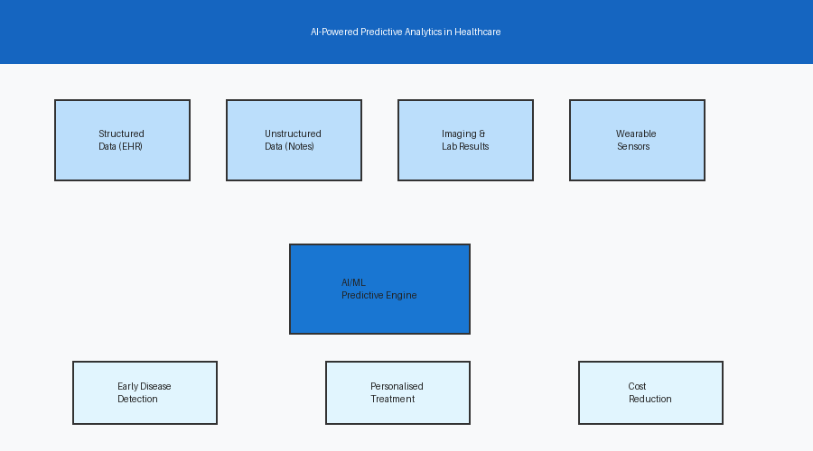
Figure 4: AI analytics engine processing multi-source patient data for predictive insights

QR Generation & Encryption | AES-256 encrypted QR tokens with rotating keys for tamper-proof patient identity
Data Integration | Apache Kafka real-time streaming; FHIR R4 adapters for all major EHR platforms
AI / ML Engine | TensorFlow risk models; NLP for clinical notes; drug-interaction graph neural networks
Patient Mobile App | React Native — QR wallet, consent manager, health insights, appointment history
Clinician Portal | React.js dashboard — instant QR scan, full patient record, AI-generated alerts
Cloud Infrastructure | AWS multi-cloud; Kubernetes orchestration; 99.99% uptime SLA

4. Expected Impact
Clinical | Operational | Patient
• 70% fewer medication errors  • Faster emergency decisions  • Better chronic disease care | • 35% less duplicate testing  • Lower admin burden  • Streamlined insurance claims | • Full health data visibility  • Portable records everywhere  • Personalised AI health tips

5. Images for Reference

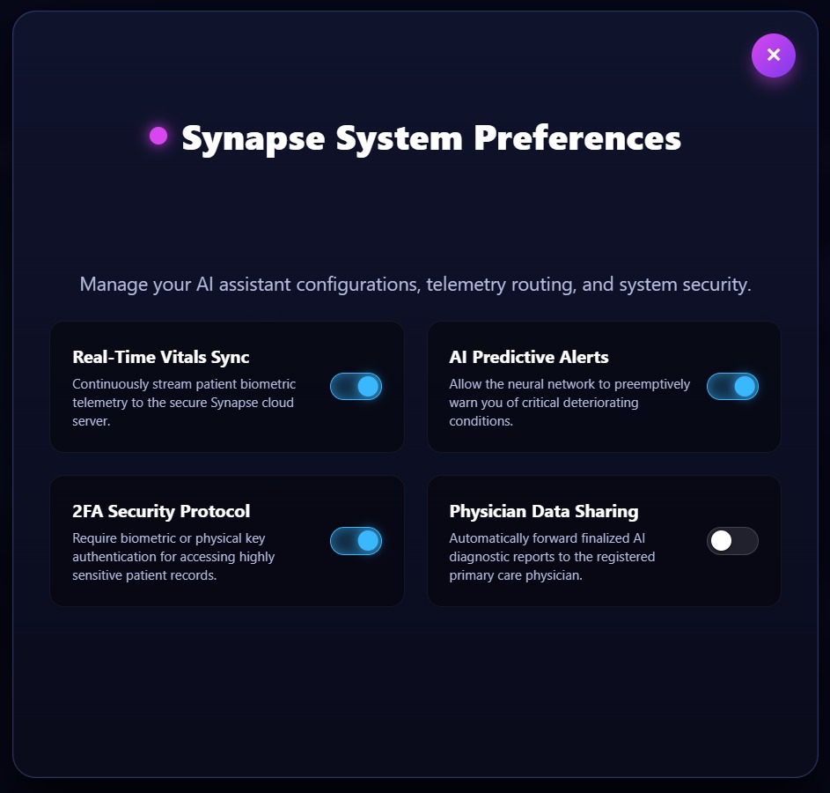

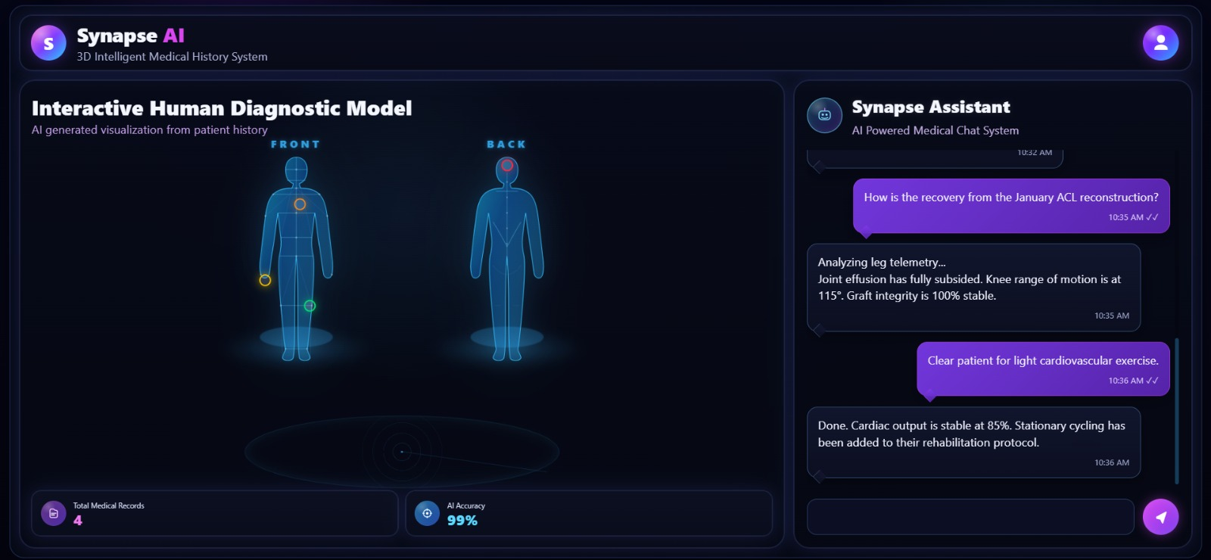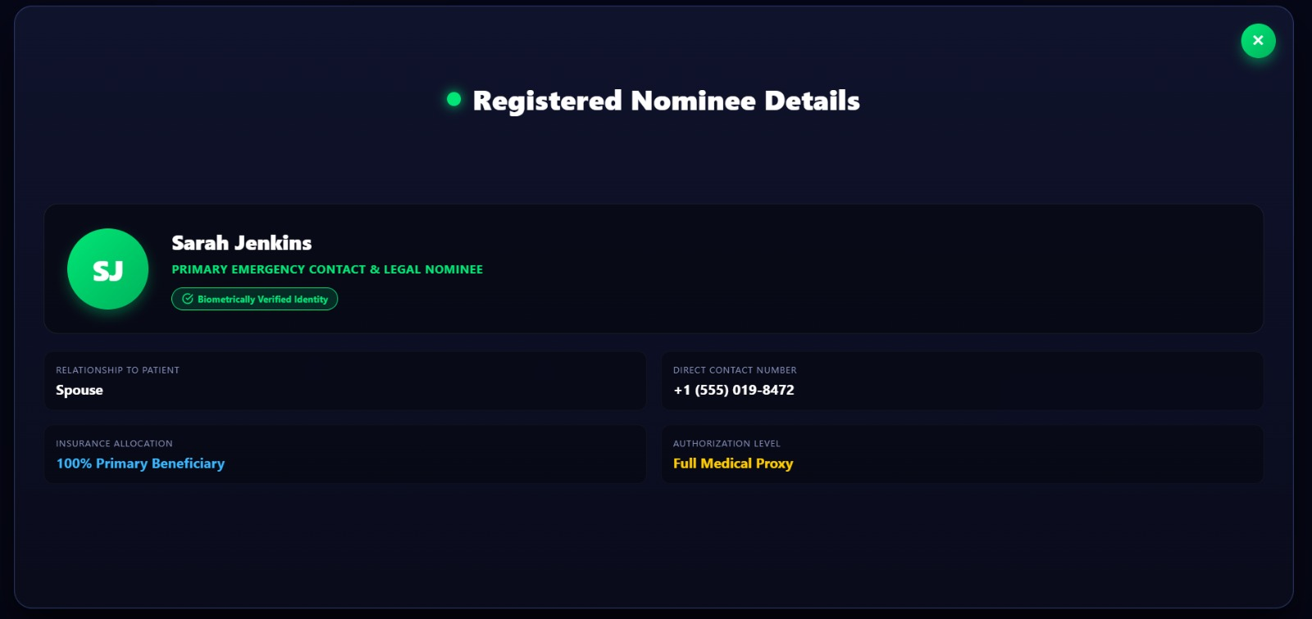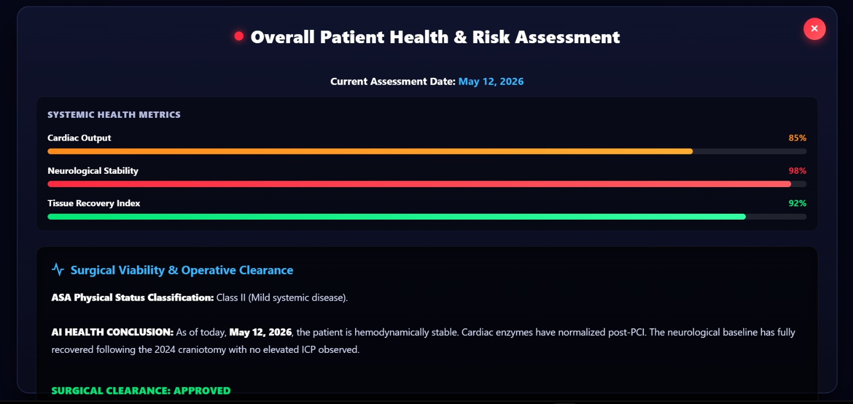

6. Conclusion
The QR Medical Record System transforms a fragmented, dangerous healthcare data landscape into a connected, intelligent ecosystem. By giving every patient one universal health identity — and every clinician instant, AI-assisted access to complete records — Team Pikhachu's solution makes healthcare safer, faster, and more human.

"One scan. Every answer. Every time."
Team Pikhachu | Aavishkar Pravah 2.0
Abhinaya S • A V Varshini Suma • Mohammed Touseef • Aiman Shariff
Unifying the Clinical Picture — One QR at a Time

